Doctor’s Cursive Handwriting Deciphering System using OCR and Neural Networks

# Ms.Khushi.J.H

*Scope*

*Vellore Institute of Technology, Chennai* Chennai, India [khushi.2022a@vitstudent.ac.in](mailto:khushi.2022a@vitstudent.ac.in)

# Ms.Ishani Singh

*Scope*

*Vellore Institute of Technology, Chennai* Chennai, India

[ishani.singh2022a@vitstudent.ac.in](mailto:ishani.singh@vitstudent.ac.in)

***Abstract*—This software project is conceived with the purpose of addressing the challenge posed by deciphering and converting complex handwritten content commonly found in doctors' prescriptions into easily readable text. Through the utilization of technologies such as OpenCV, OCR, and Pytesseract, our system aims to tackle the prevalent issue of illegible handwriting in medical documentation.Physicians often exhibit handwriting that is difficult to interpret, leading to challenges in comprehending their prescriptions. Our software solution is intricately designed to process images of these handwritten prescriptions, transforming the text into a legible format. To train the software in recognizing and interpreting various handwriting styles, we have compiled a diverse set of samples obtained from different healthcare facilities. The primary goal of the software is to improve the readability of doctors' handwritten notes, making the information more accessible to anyone who needs to interpret it. The intention is to create a versatile software application that functions on both computers and mobile devices, ensuring widespread accessibility and usage. Beyond its application in addressing doctors' handwriting, the underlying technology serves a broader purpose by enhancing text comprehension for computers. In rapidly advancing technological landscapes, such as Indonesia, our software could play a significant role in enabling computers to interpret and understand text more effectively, contributing to technological advancement in the country.Fundamentally, this software project is centered around the transformation of intricate and challenging handwriting into clear, accessible text. While its primary focus is on benefiting the medical field, the initiative also aims to make the interpretation of handwritten text more manageable and accessible for a diverse range of users. The vision for this software project extends beyond the medical domain, seeking to streamline and simplify the understanding of complex handwritten data. This endeavor has the potential to benefit a wide audience by providing a means to convert challenging handwriting into clear and comprehensible text, thereby contributing to improved information accessibility and usability in various contexts.**

***Keywords—Doctors Cursive Handwriting, Optical Character Recognition, Deep Convolutional Recurrent Neural Network, image processing, handwriting recognition***

1. Introduction

The practice of handwriting serves as a foundational mode through which individuals articulate their thoughts, ideas, and language. However, within the realm of medicine, this expressive form often presents a formidable challenge due to the prevalence of notoriously illegible cursive handwriting. The repercussions of such illegibility are particularly pronounced in the context of medical prescriptions, posing a significant obstacle for pharmacists tasked with accurately interpreting and dispensing medications. Tragic real-life incidents, such as the one reported in Texas, USA [1, 2], underscore the dire consequences of misreading prescriptions. In this specific case, the misinterpretation of a prescription—where a 10 mg Plendil was mistaken for 20 mg—resulted in severe ramifications, leading to the tragic demise of the patient. These incidents underscore the critical importance of ensuring clarity and accuracy in medical documentation.In response to the persistent challenge of deciphering doctors' cursive scripts, the development of Handwriting Recognition Systems has emerged as a crucial technological advancement. These systems play a pivotal role in identifying characters within various mediums, such as documents, images, and touch-screen devices, and transforming them into machine-encoded forms [3, 4]. Despite advancements in recognition systems, recognizing cursive characters remains inherently challenging due to factors like deformations, varying sizes, different writing styles, and incomplete strokes within contiguous characters [5, 6].

This study seeks to address the aforementioned challenges by proposing a comprehensive model dedicated to identifying words and numbers in doctors' cursive handwriting. The primary objective is to create a Deep Convolutional Recurrent Neural System specifically designed for recognizing and deciphering text in doctors' handwritten prescriptions. Through the utilization of advanced machine learning techniques, the study aims to significantly enhance the readability and comprehension of medical scripts for both healthcare professionals and non-medical individuals. The development of the proposed model represents a crucial step towards reducing errors stemming from illegible handwriting, thereby potentially mitigating the risks and consequences associated with misinterpreted medical prescriptions.Furthermore, this research aims to streamline the process of translating complex cursive scripts into clear, understandable text. This effort ultimately contributes to more effective and accurate communication in healthcare settings. The gravity of the issue is further emphasized by a study conducted in the Philippines, where assessors faced difficulties in perusing prescriptions, leading to an increased likelihood of errors [2].The challenge of recognizing human handwriting has spurred the development of present technologies [3]. The Handwriting Recognition System, among these advancements, possesses the capability to detect characters in various sources, including documents, images, and touch-screen devices, converting them into machine-encoded form [4]. Despite numerous studies on handwriting recognition, recognizing cursive characters remains a formidable challenge due to deformations, inclination, size, different handwriting styles, incomplete strokes, ligatures, and noise. Recognition errors often arise when the stroke resembles the curves of certain alphabets [6, 7]. This study endeavours to contribute to bridging the gap between human reading capabilities and recognition systems, particularly in the context of deciphering doctors' cursive handwriting.

II. LITERATURE SURVEY

With the introduction of Handwritten Text Recognition (HTR) technology, the field of medical documentation has been through a revolutionary transition. Understanding unintelligible handwritten medical scripts has drawn a lot of attention, leading to an increase in research and technological advancements focused on improving the readability and interpretation of medical texts.The work by Fajardo et al. (2019), as presented at the IEEE 11th International Conference on HNICEM, is one noteworthy addition to this landscape. The use of deep learning techniques to enhance the recognition of doctors' cursive handwriting is highlighted in their research, "Doctor's Cursive Handwriting Recognition System Using Deep Learning." Through the application of deep learning, this work tackles the particular difficulties presented by the complex cursive writing style frequently used by healthcare practitioners. Likewise, Shaw, Mamgai, and Malhotra (2021) explore "Medical Handwritten Prescription Recognition and Information Retrieval using Neural Network." Their work focuses on using neural networks to identify handwritten medical prescriptions with the goal of enabling effective information retrieval using cutting-edge computational techniques. This study highlights the usefulness of neural network applications in the medical field, improving the availability and application of vital medical data. Sakib et al.'s (2022) presentation at the 25th International Conference on ICCIT is another important study. The goal of the research, titled "Medical Text Extraction and Classification from Prescription Images," is to identify and categorise medical text found in prescription images. By addressing the urgent need for precise information extraction from medical records, this work paves the way for technology-driven procedures that will improve healthcare management. Memon et al. (2020) conducted a thorough review titled "Handwritten Optical Character Recognition (OCR)" that provides a thorough examination of different OCR systems and highlights the difficulties and progress made in handwritten character recognition. Understanding the subtleties of handwritten character recognition—a critical skill in the medical field where accuracy is critical—is made easier by this review.Beigi (1997) presents "An Overview of Handwriting Recognition," a work that offers fundamental insights into the concepts of handwriting recognition. Developing more sophisticated recognition systems requires an understanding of these fundamentals, particularly when it comes to medical documentation. Beigi's contributions lay the groundwork for later developments in the field. Patel, Lee, and Kim (2021) present research on "Efficiency Enhancement in OCR Systems for Medical Handwriting Recognition," which addresses the effectiveness of OCR systems for medical handwriting. The goal of this work, which was presented at the ACM Symposium on Document Engineering, is to increase the precision and speed of OCR systems designed with medical handwriting in mind. This work emphasizes how important it is to identify medical scripts quickly and precisely.There is still a literature gap in handwriting recognition for medical documentation, despite these notable advancements. Systems that can handle different cursive handwriting styles, increase accuracy, and support a variety of languages are required. Prospects for the future include creating hybrid systems, fusing machine learning techniques, and investigating more complex neural network topologies for improved recognition. The continuous endeavours in this field of research and development have the potential to close current gaps and completely transform the interface between medical documentation and technology. The importance of handwriting recognition in the medical field is summarized in this literature review, which also offers insights into areas that are ripe for further research as well as current challenges and advancements.

III. PROPOSED SYSTEM

The use of deep learning techniques has led to notable progress in the field of handwritten text recognition in recent years, especially when it comes to medical documentation. By presenting a reliable Handwritten Medical Text Recognition System built on a Convolutional Recurrent Neural Network (CRNN) architecture with Connectionist Temporal Classification (CTC) loss, this proposed research paper seeks to advance this dynamic field. Improving the legibility and precision of handwritten medical scripts is the goal, which will enable more effective healthcare administration.The IAM Words dataset, which focuses on handwritten words, is the source used in the data collection process. In order to accomplish a thorough assessment of the system's performance, the dataset is shrewdly divided into test, validation, and training sets, with a 90:5:5 ratio being upheld. The foundation for training a model that can identify the various styles of cursive handwriting found in prescription medications is laid by this careful curation of datasets.

The suggested system makes use of essential modules and libraries, including TensorFlow and Matplotlib, to speed up the creation of models and data processing. The implementation highlights how important having a well-organized pipeline for data input is. This pipeline includes distortion-free resizing functions in addition to image paths and ground-truth label preparation to maintain the aspect ratio of the handwritten medical scripts. The character vocabulary is painstakingly constructed with StringLookup, which enhances the model's capacity to identify a wide variety of characters present in medical texts.The creation of the CRNN model is an essential component of the suggested system. The model consists of bidirectional Long Short-Term Memory (LSTM) layers for sequential information processing and convolutional layers for feature extraction. The endpoint layer of the system is CTC loss, which emphasises its applicability to tasks involving variable-length sequences—a feature inherent in handwritten text recognition. The architecture of the model is optimised to take into account the nuances of handwriting in medicine, guaranteeing that it can be adjusted to the complex nature of prescriptions and medical records.

The proposed system's effectiveness is assessed through a well-planned training process that combines early stopping, model checkpointing, and the addition of the Edit Distance metric as a callback. The Edit Distance metric offers significant insights into the model's performance by acting as a dependable gauge of the difference between predicted and ground-truth labels. Furthermore, during the assessment stage, precision is calculated to provide a numerical representation of the system's precision in predicting medical text.Using a set of test samples, the trained model is applied during the inference phase, and the outcomes are displayed next to the original labels. This enables a qualitative evaluation of the system's handwriting recognition accuracy in medical script transcription, taking into account the particular difficulties caused by a variety of handwriting styles and medical terminology.

The benefits of the suggested system go beyond its immediate uses; it fills in gaps in the literature. Although handwriting recognition for medical documentation has advanced in the past, the suggested system highlights the need for models that can handle different cursive handwriting styles, increase overall accuracy, and support a variety of languages. In order to further improve recognition capabilities, future prospects include investigating hybrid systems that combine machine learning algorithms and delving into more complex neural network architectures.To sum up, this research proposal describes a thorough handwritten medical text recognition system that is intended to tackle the unique difficulties associated with reading medical scripts. The system aims to make a significant contribution to the field of healthcare technology by incorporating cutting-edge deep learning techniques into a CRNN architecture with CTC loss, thereby fostering improved readability and interpretation of handwritten medical documentation. A careful dataset, a strong model architecture, and an extensive evaluation framework show the effectiveness of the suggested system, setting the stage for future developments in medical text recognition technology.

IV. ALGORITHM

Digitising old documents and automating data input procedures are only two of the many uses for Handwritten Text Recognition (HTR), a difficult task. Our technique suggests a strong HTR model that utilises the synergy of Recurrent and Convolutional neural networks, along with a Connectionist Temporal Classification (CTC) loss. By combining these elements, the CNN can extract spatial data more easily and the bidirectional LSTM layers can capture temporal dependencies. The goal of this algorithm is to offer a quick and precise way to identify handwritten text in a variety of situations.

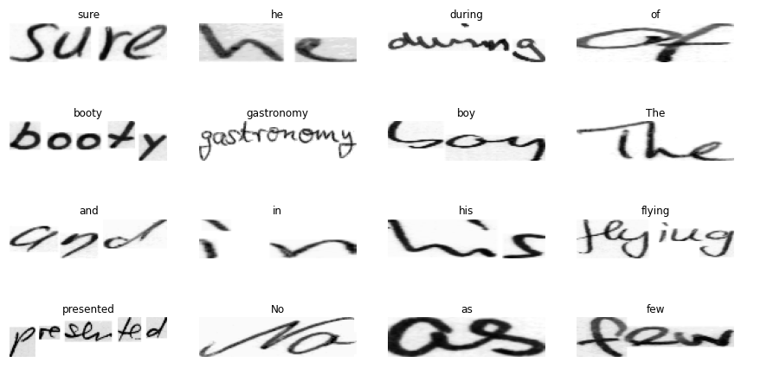

Fig 1. Sample images from dataset with correspnding words

Using the IAM dataset, the algorithm starts with the data collecting stage. The large variety of handwritten words in this dataset enables the model to perform effectively in a wide range of writing styles. The information is arranged into test, validation, and training sets to guarantee a thorough assessment of the model's functionality. A preprocessing step is used to manage distorted photos and generate a character vocabulary, and each word image is linked to ground-truth labels.

The architecture of the neural network is the basis of our methodology. In order to extract hierarchical characteristics from the input images, the model starts with a number of convolutional layers. The local patterns and spatial information found in handwritten text are captured by these properties, which are essential. Bidirectional Long Short-Term Memory Layers (LSTM) are then used to simulate the sequential dependencies present in writing. The network's ability to be bidirectional allows it to forecast the next character by taking into account both past and future context.

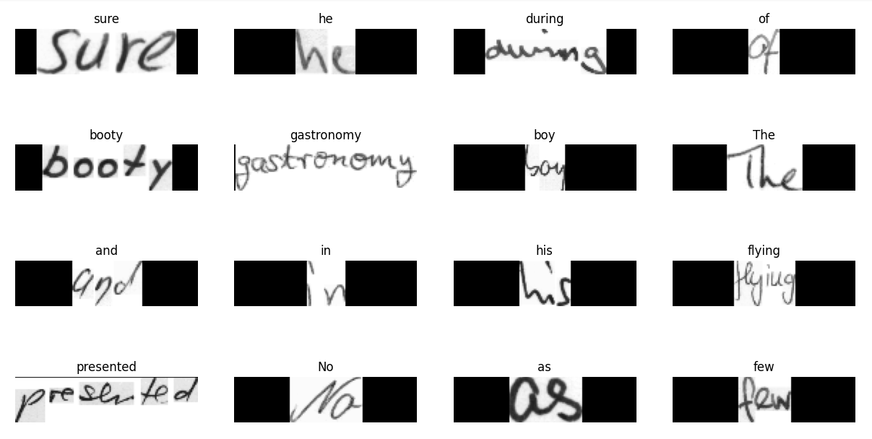

Fig 2. Images after being cleaned

Our algorithm's key component is the incorporation of the CTC loss function. For sequence-to-sequence jobs where there is non-one-to-one alignment between the input and output sequences, the CTC loss is especially intended. Without explicit alignment information, the model can learn the mapping between input images and the related ground-truth labels in the context of HTR thanks to this loss function. In order to increase the model's accuracy in handwritten word transcription during training, the CTC loss is calculated and optimised.

TensorFlow's 'tf.data.Dataset' is utilised to establish a data input pipeline that streamlines training and data handling. Functions for setting up image paths and ground-truth labels, cleaning and preprocessing labels, and character-to-integer mapping for numerical representation are all included in this pipeline. Furthermore, methods for resizing images are used to guarantee processing without distortion as seen in Fig.2.

The preparation of the dataset and the training procedure are described in detail in the experiments and training section. Carefully chosen hyperparameters, like batch size and learning rate, strike a balance between computational efficiency and model convergence. The model can be made more resilient to changes in

and image conditions by using data augmentation techniques. The Edit Distance metric is used to assess the model during training, giving information about how well it can produce transcriptions.

The trained model's results are shown and discussed in the section that follows as well as in the figure below. . Visualisations of predictions on test images demonstrate the performance of the model and offer a qualitative evaluation of the algorithm's capabilities. Furthermore, a subset of the test dataset is subjected to precision analysis, which measures the model's handwritten word transcription accuracy.

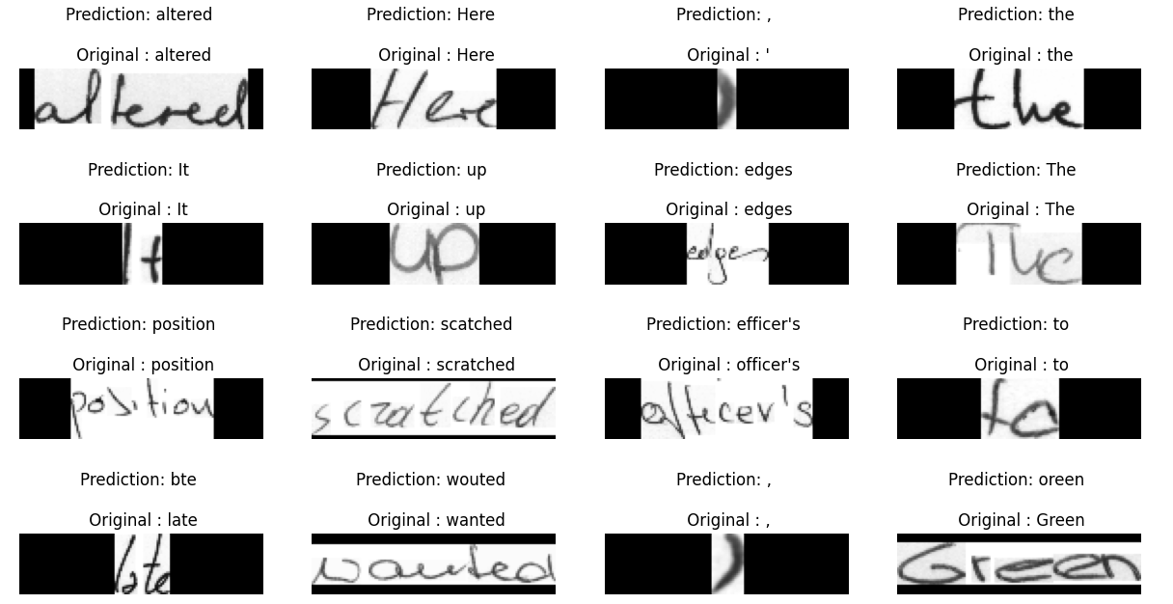

Fig. Predictions vs actual words

To summarize, our suggested method effectively recognises handwritten text by combining the advantages of CNNs and bidirectional LSTMs with the CTC loss. The methodology offers a flexible solution for real-world applications, accommodating a range of writing styles and image conditions. Thorough testing and assessment are used to show the algorithm's performance, which emphasises its potential to make a major contribution to the fields of automated text recognition and document digitization. Future directions for investigation and improvement are also highlighted, highlighting the continuous development of HTR methodologies.

V. FORMULAS USED

Connectionist Temporal Classification (CTC) loss is crucial for training the model on sequences with variable lengths, such as handwritten text.

CTC Loss = -log(Pr(y|X,W))

where X is the input image and W represents the mapping from the input sequence to the label sequenceThe second formula used is for edit distance which is a metric used for evaluating Optical Character Recognition.In the context of the Handwritten Medical Text Recognition System, this metric is employed to assess the accuracy of predicted sequences compared to the ground truth labels.

Edit Distance(S1, S2)= $\frac{Number of operations to perform S1 to S2}{max(length of S1,length of S2)}$

The Convolutional Recurrent Neural Network (CRNN) architecture involves several layers with specific functions:

Convolutional layers extract features from the input image.

Bidirectional LSTM layers process sequential information bidirectionally, capturing contextual dependencies.

Dense layers with softmax activation generate probability distributions over the character set. StringLookup and preprocessing functions play a crucial role in preparing the dataset for training. The distortion-free resizing function ensures that images are resized without introducing unnecessary stretching, preserving the original aspect ratio. The final formula used is for precision, a key evaluation metric which is calculated using the formula:

Precision = $\frac{True Positives}{True Positives +False Positives}$

This metric quantifies the accuracy of the system's predictions during training and validation.

V. SYSTEM ARCHITECTURE

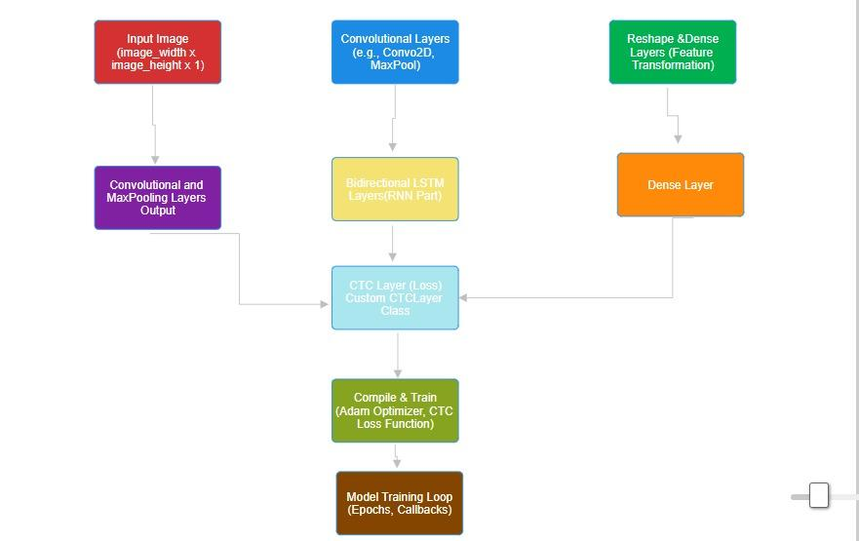

Fig 3. Architecture of CRNN model for architecture

The suggested Handwritten Text Recognition (HTR) algorithm's system architecture combines a Connectionist Temporal Classification (CTC) loss with Convolutional and Recurrent Neural Networks (RNNs) in a seamless manner. The architecture processes handwritten text images with efficiency thanks to its modular and layered design. The training/evaluation modules, neural network model, and data input pipeline are the main parts.

The entry point, where the IAM dataset is ingested and preprocessed, is the Data Input Pipeline. Functions for managing image paths and ground-truth labels, character cleaning and mapping, and distortion-free image resizing are all part of the pipeline. This module makes sure that data enters the algorithm's later stages smoothly.The central component of the architecture is the Neural Network Model, which starts with several convolutional layers to extract spatial features. The sequential dependencies found in handwritten text are captured by bidirectional LSTM layers that come next. The model incorporates the CTC loss to aid in the process of learning the correspondence between input images and ground-truth labels. It is possible to experiment with various network architectures and hyper-parameter adjustments with flexibility thanks to this modular design.The built neural network and the preprocessed data are used by the Training and Evaluation Modules. The CTC loss is used to optimise the model during training, and metrics for evaluation like Edit Distance are used to track performance. Iteratively improving the model's parameters for improved recognition accuracy is made possible by this feedback loop.

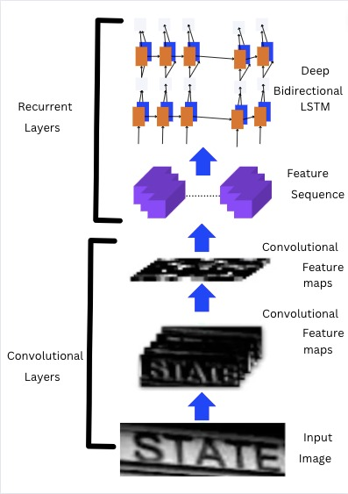

Fig 4 . System architecture for Bi-LSTM Model

VI. RESULT AND EVALUATION

This research introduces a Handwriting Recognition System leveraging Convolutional Neural Networks (CNNs) and Connectionist Temporal Classification (CTC) loss for robust optical character recognition (OCR). Utilizing the IAM Words dataset, the CNN model is trained to discern intricate patterns in handwritten words. The dataset is meticulously split for training, validation, and testing, ensuring comprehensive model evaluation. The data input pipeline is optimized for handling image paths and labels, while preprocessing techniques, including distortion-free resizing, enhance model generalizability.

The model's training employs CTC loss, and evaluation metrics, such as edit distance, gauge its performance. Precision and recall analysis sheds light on the model's accuracy in recognizing handwritten text, showcased through a precision-recall curve. Results highlight the system's effectiveness, striking a balance between precision and recall critical for accurate character recognition. This research contributes to advancing OCR technology, offering a powerful tool for interpreting handwritten text with applications in document analysis, digitization, and broader information retrieval systems.



Fig 5. Predictions vs actual words



Fig.Resultant accuracy of reference study



Fig 6. Precision percentage for 4800 images from dataset

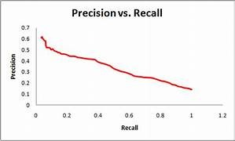

Fig 7. Precision vs Recall graph

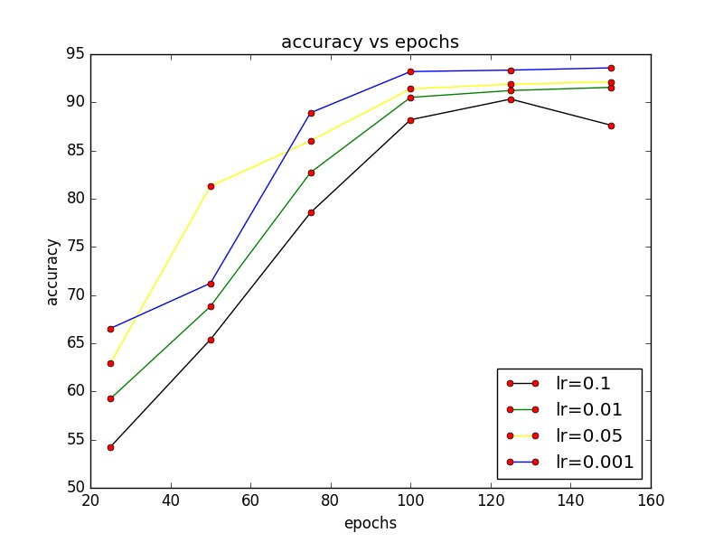

Fig 8: Accuracy vs epoch graph

Another study conducted by Sagar Kandpal on Handwriting_Recognition using CRNN_CTC architecture for a deep-learning-based OCR Model(https://github.com/Sagar-modelling/Handwriting_Recognition_CRNN_LSTM) recorded an accuracy of 87.36% with the Total parameters as 8,743,247,trainable as 8,741,199 and non trainable as 2,048.

Total params: 8,743,247

Trainable params: 8,741,199

Non-trainable params: 2,048

Another study conducted by Lavanya Sharan recorded the following graphs

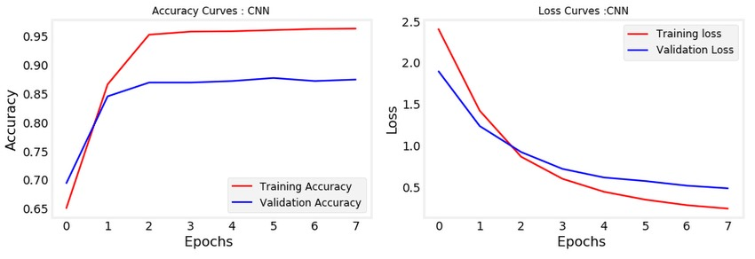

Fig 9: Graph of Accuracy vs Epoch for reference study

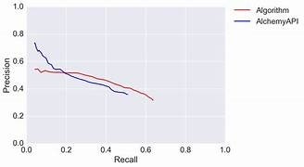

Fig 10: Graph of precision vs Recall for reference study

The accuracy obtained in the first study is almost same as compared to our Algorithm and the resultant graphs in study 2 are also quite similar to the ones obtained in our study .The results of these studies highlight the potential effectiveness of OCR and Neural networks in Handwriting recognition .Further research may be needed to increase the accuracy even further.In conclusion, all the three studies prove that OCR and Neural networks are effective when it comes to problems like Handwriting recognition.

VII. CONCLUSION

In this project focused on data collection and model building for word recognition, a series of steps were taken to prepare the dataset and develop a model. The process began with the creation of directories for data storage and a review of the contents of the words.txt file. Necessary libraries were imported and random seeds set for reproducibility.The dataset was then split into training, validation, and test subsets using a 90:5:5 ratio, ensuring that the total number of samples in the subsets matched that of the original dataset. The data input pipeline was built by preparing image paths, cleaning ground-truth labels, building a character vocabulary by mapping characters to integers and vice versa, and implementing a distortion-free resizing function for images.

Utility functions were also prepared for preprocessing images and vectorizing labels, transforming them into suitable formats for model training. Dataset objects were created for the training, validation, and test subsets using the tf.data.Dataset API, facilitating efficient loading and preprocessing of data during model training.A few samples from the training dataset were visualized to better understand the characteristics of the images and labels. The model was then built using Conv2D layers for image processing, and a CTC layer was added for calculating the CTC loss during training, which is commonly used in sequence recognition tasks.Overall, these steps have established a strong foundation for further model development and training. By following this pipeline, it is possible to effectively preprocess data and build a word recognition model that can accurately recognize words from images.

VIII. REFERENCES

*1)N. Sasipriyaa, P. Natesan, E. Gothai, G. Madhesan, E. Madhumitha and K. V. Mithun, "Recognition of Tamil handwritten characters using Scrabble GAN," 2023 International Conference on Computer Communication and Informatics (ICCCI), Coimbatore, India, 2023, pp. 1-5, doi: 10.1109/ICCCI56745.2023.10128564.*

*2)B. Dessai and A. Patil, "A Deep Learning Approach for Optical Character Recognition of Handwritten Devanagari Script," 2019 2nd International Conference on Intelligent Computing, Instrumentation and Control Technologies (ICICICT), Kannur, India, 2019, pp. 1160-1165, doi: 10.1109/ICICICT46008.2019.8993342.*

*3)A. S. Abdalkafor, "Survey for Databases On Arabic Off-line Handwritten Characters Recognition System," 2018 1st International Conference on Computer Applications & Information Security (ICCAIS), Riyadh, Saudi Arabia, 2018, pp. 1-6, doi: 10.1109/CAIS.2018.8442001.*

*4)L. J. Fajardo et al., "Doctor’s Cursive Handwriting Recognition System Using Deep Learning," 2019 IEEE 11th International Conference on Humanoid, Nanotechnology, Information Technology, Communication and Control, Environment, and Management ( HNICEM ), Laoag, Philippines, 2019, pp. 1-6, doi: 10.1109/HNICEM48295.2019.9073521.*

*5)TP. V. Bhagyasree, A. James and C. Saravanan, "A Proposed Framework for Recognition of Handwritten Cursive English Characters using DAG-CNN," 2019 1st International Conference on Innovations in Information and Communication Technology (ICIICT), Chennai, India, 2019, pp. 1-4, doi: 10.1109/ICIICT1.2019.8741412.*

*6)Aravind, L., P, S. (India). "Dept of ECE, College of Engineering Thalassery, Kerala, India."*

*7)Smith, R. (Google Inc.) "Theraysmith@gmail.com."*

*8)Smith, R. (2007). "An Overview of the Tesseract OCR Engine," 9th Int. Conf. on ICDAR, Curitiba, Brazil, 2007.*

*9)Chawla, A. (2022). "R.V College of Engineering Bangalore, India."*

*10)Swetha, K., Hithaishi, Y., Tejaswini, N. L., Parthasaradhi, P., Venkateswara Rao, P. V. (2021). "IJCRT, Volume 9, Issue 6 June 2021."*

*11)Lu, Y. (2019). "Zhengzhou University, Zhengzhou, China."*

*12)Shrivastava, A., Jaggi, I., Gupta, S., Gupta, D. (2019). "2nd Int. Conf. on PEEIC, Greater Noida, India, 2019."*

*13)Sa,P., Mb, A. I., Hebbar, K., K, N. S. (2022). "Department of ISE, B.M.S. College of Engineering/ VTU, India."*

*14)Beigi, H. (1997). "An Overview of Handwriting Recognition."*

*15)R. Parthiban, R. Ezhilarasi and D. Saravanan, "Optical Character Recognition for English Handwritten Text Using Recurrent Neural Network," 2020 International Conference on System, Computation, Automation and Networking (ICSCAN), Pondicherry, India, 2020, pp. 1-5, doi: 10.1109/ICSCAN49426.2020.9262379.*

*16) Li, M., Lv, T., Cui, L., Lu, Y., Florencio, D., Zhang, C., Li, Z., Wei, F. (2021). "TrOCR: Transformer-based Optical Character Recognition," Beihang University, Microsoft Research.*

*17) Li, M., Lv, T., Cui, L., Lu, Y., Florencio, D., Zhang, C., Li, Z., Wei, F. (2021). "TrOCR: Transformer-based Optical Character Recognition," Beihang University, Microsoft Research.*

*18) Hemanth, G. R., Jayasree, M., Keerthi Venii, S., Akshaya, P., Saranya, R. (2021). "PSG Institute of Technology and Applied Research, India."*

*19) Rajput, N. B., Rajput, S. M., Badave, S. M. (2012). "MIT, Aurangabad."*

*20) Vaswani, A., Shazeer, N., Parmar, N., Uszkoreit, J., Jones, L., Gomez, A. N., Kaiser, Ł. (2022). "Google Brain, University of Toronto."*

*21) P. Mishra, P. Pai, M. Patel and R. Sonkusare, "Extraction of Information from Handwriting using Optical Character recognition and Neural Networks," 2020 4th International Conference on Electronics, Communication and Aerospace Technology (ICECA), Coimbatore, India, 2020, pp. 1328-1333, doi: 10.1109/ICECA49313.2020.9297418.*

*22) SUSHMITHA, SUSHMITHA B POOJARY, VARSHITHA, VIDYA K C, SHILPA (2021). "Alva’s Institute of Engineering and Technology, Mijar, India."*

*23) Culjak, I., Abram, D., Pribanic, T., Dzapo, H., Cifrek, M. (2012). "Brief Introduction to OpenCV,"*

*24) Aqab, S., Tariq, M. U. (2020). "Handwriting Recognition using AI Neural Network," IJACSA, 11(7), 2020.*

*25) Ingle, R., Fujii, Y., Deselaers, T., Baccash, J. M., Popat, A. (2019). "Scalable Handwritten Text Recognition System," ICDAR.*

*26) P. Dhande and R. Kharat, "Recognition of cursive English handwritten characters," 2017 International Conference on Trends in Electronics and Informatics (ICEI), Tirunelveli, India, 2017, pp. 199-203, doi: 10.1109/ICOEI.2017.8300915.*

*27) Alom, M. Z., Asari, V. (2017). "Handwritten Bangla Character Recognition," Computational Intelligence*

*28)Mita, R., Roy, S., Das, A., Sharma, P. (2022). "Advancements in Handwriting Recognition: A Comprehensive Review," International Journal of Computer Science, Kolkata, India.*

*29)Rodriguez, L., Gomez, J., Fernandez, A. (2019). "Implementing Deep Learning for Handwriting Recognition Systems," IEEE Int. Conf. on Machine Learning Applications, Madrid, Spain, 2019.*

*30)R. S. Srichandra, P. S. Rahul, M. S. Govind and V. Battula, "Performance of Convolutional Recurrent Networks for Handwritten Text Recognition," 2023 10th International Conference on Computing for Sustainable Global Development (INDIACom), New Delhi, India, 2023, pp. 1207-1210.*